Lab Report-1

(Sanchit jalan,Group-3,2022101070)

**Experiment 1 :-**

Objective:- Familiarization with digital test kit and Binary Logic Levels .

Electronic Components Required:-

1) Breadboard

2) 7404 IC

3) Wires

4) Led

5) Switch

6) Power Supply

7) Resistor

Reference circuit of TinkerCAD:-

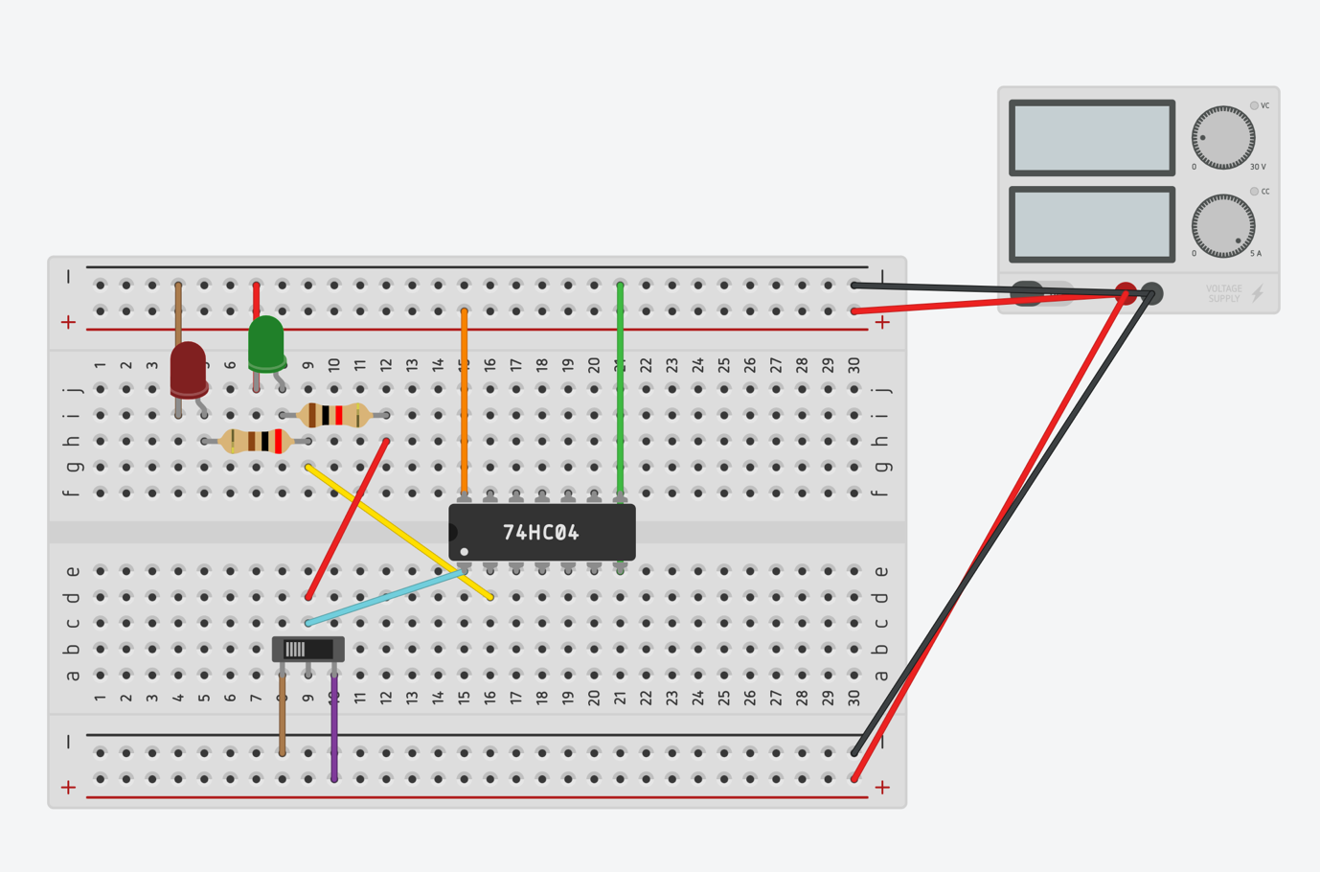

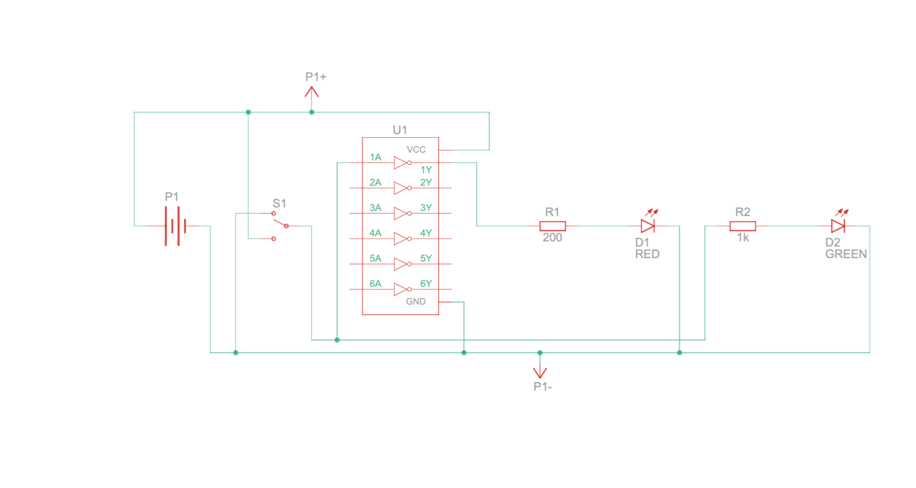

Procedure:-

1)Connect the not gate(7404 IC) on the breadboard connecting it to the ground and power supply

2)Connect the input and subsequent output terminals of the not gate with connecting wires..

3)Input terminal with the input switch and output terminal of the not gate with the led switches…

Observation:-

We observe that :-

1)When the input is high not gate inverts the input and then output is low so the green led glows

2)When the input is low not gate inverts the input to high and then the red light glows…

Simulation link:-

https://www.tinkercad.com/things/ijbK569fc5C?sharecode=ko9i1w2ij-a59RV_Y0DYFNuCRILpey5Dhpx8HV4vWkI

**Experiment 2:-**

Objective:- To output “Hello World” on serial monitor when output of not gate is 1 and “Bye” when output is 0 …

Electronic components required:-

1)Arduino UNO ISP

2)7404 IC

3)Power supply

4)Slideswitch

5)Connecting wires

6)Breadboard

Reference circuit of TinkerCAD:-

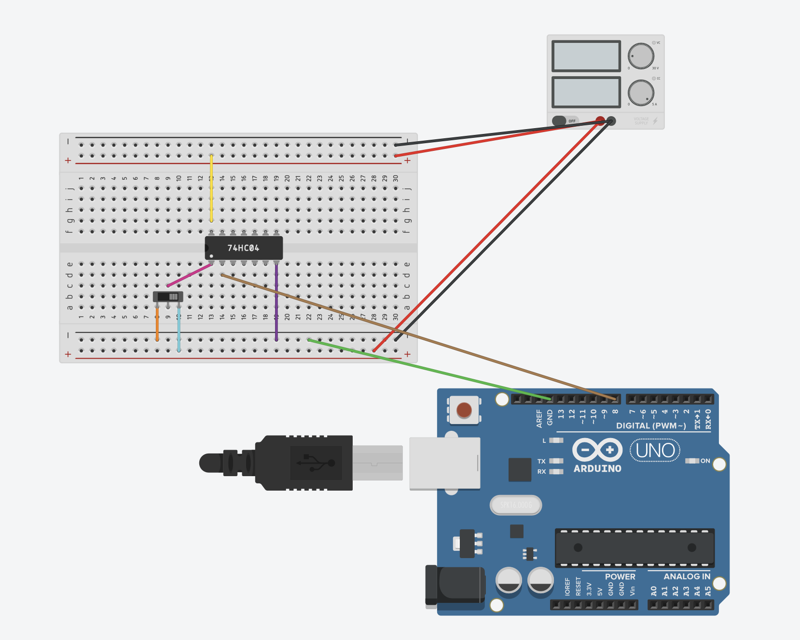

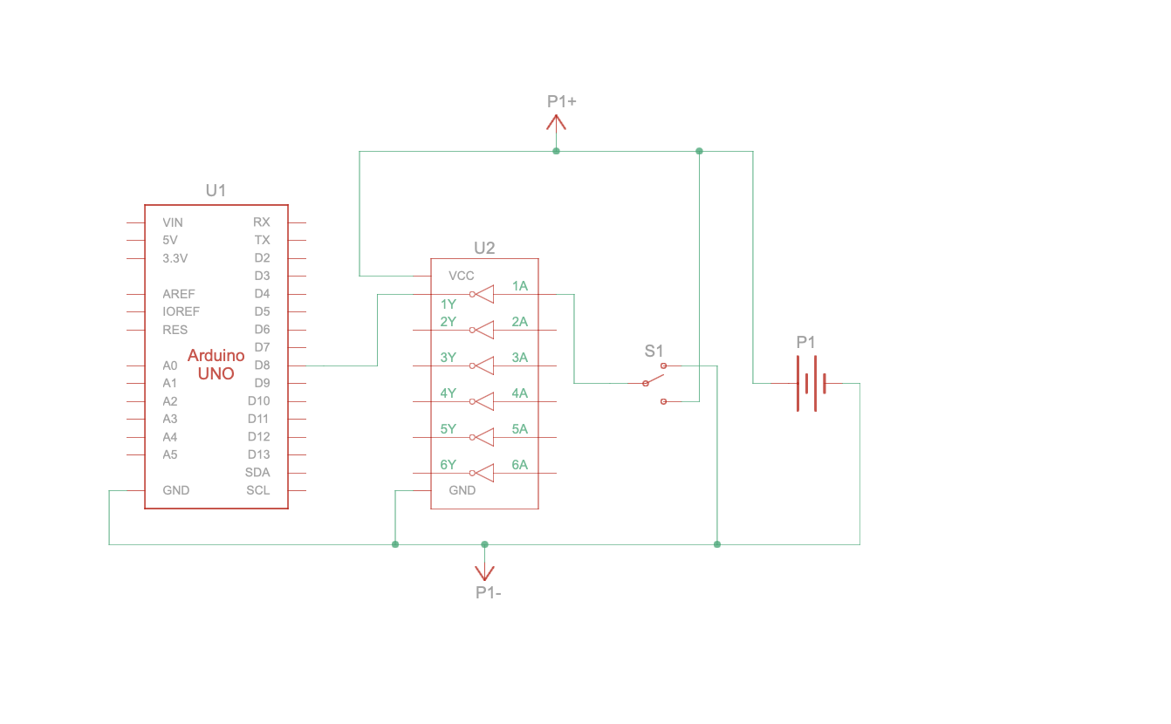

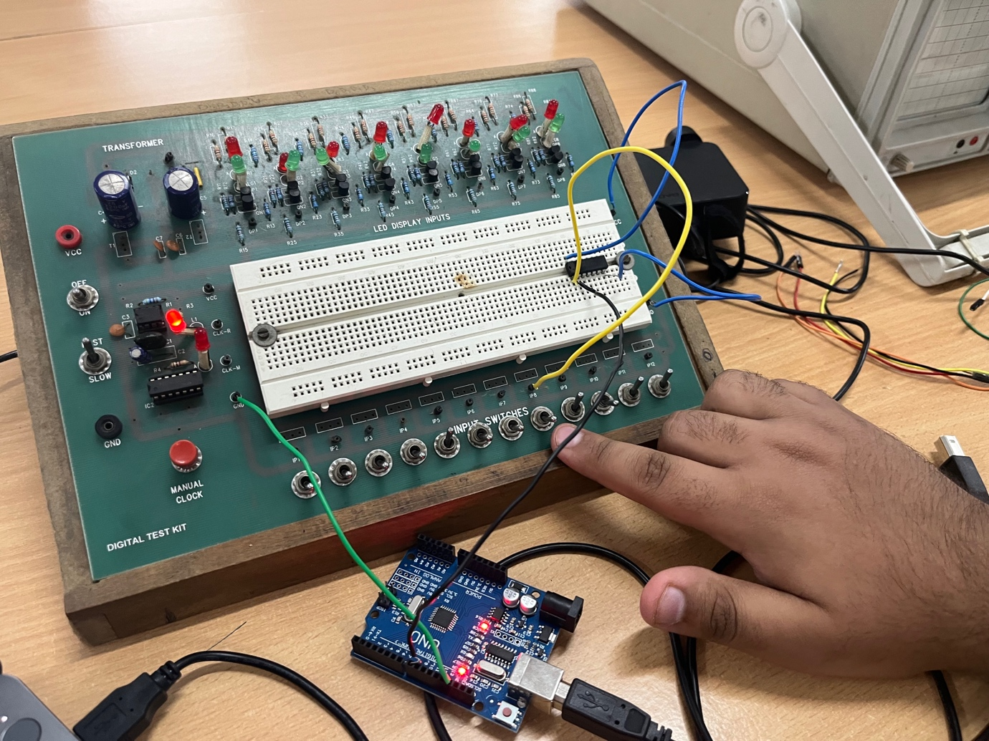

Procedure:-

1)Connect the Arduino UNO to the laptop.

2)Connect the input of the slideswitch to NOT gate input . Connect the output terminal of the NOT gate to Arduino INPUT.

3) Make appropriate connections of NOT gate and Arduino ISP to GND and power supply ..

Code :-

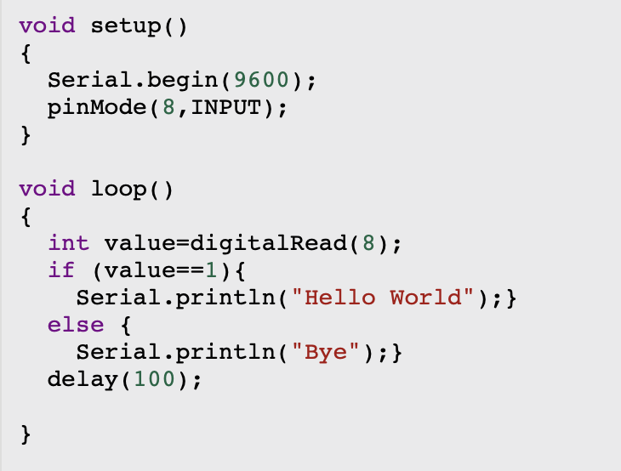

Observation:-

1)When the input is HIGH NOT gate inverts the input and converts it to LOW and BYE is printed on the serial monitor ..

2) When the input is LOW NOT gate inverts the input and converts it to HIGH and HELLO WORLD is printed on the serial monitor ….

Simulation link:-

https://www.tinkercad.com/things/3uAB0wUDnYN?sharecode=x6Ln7N0mixhlagNzTsRSLa04AtS9VmhG4x4kexyaOjA